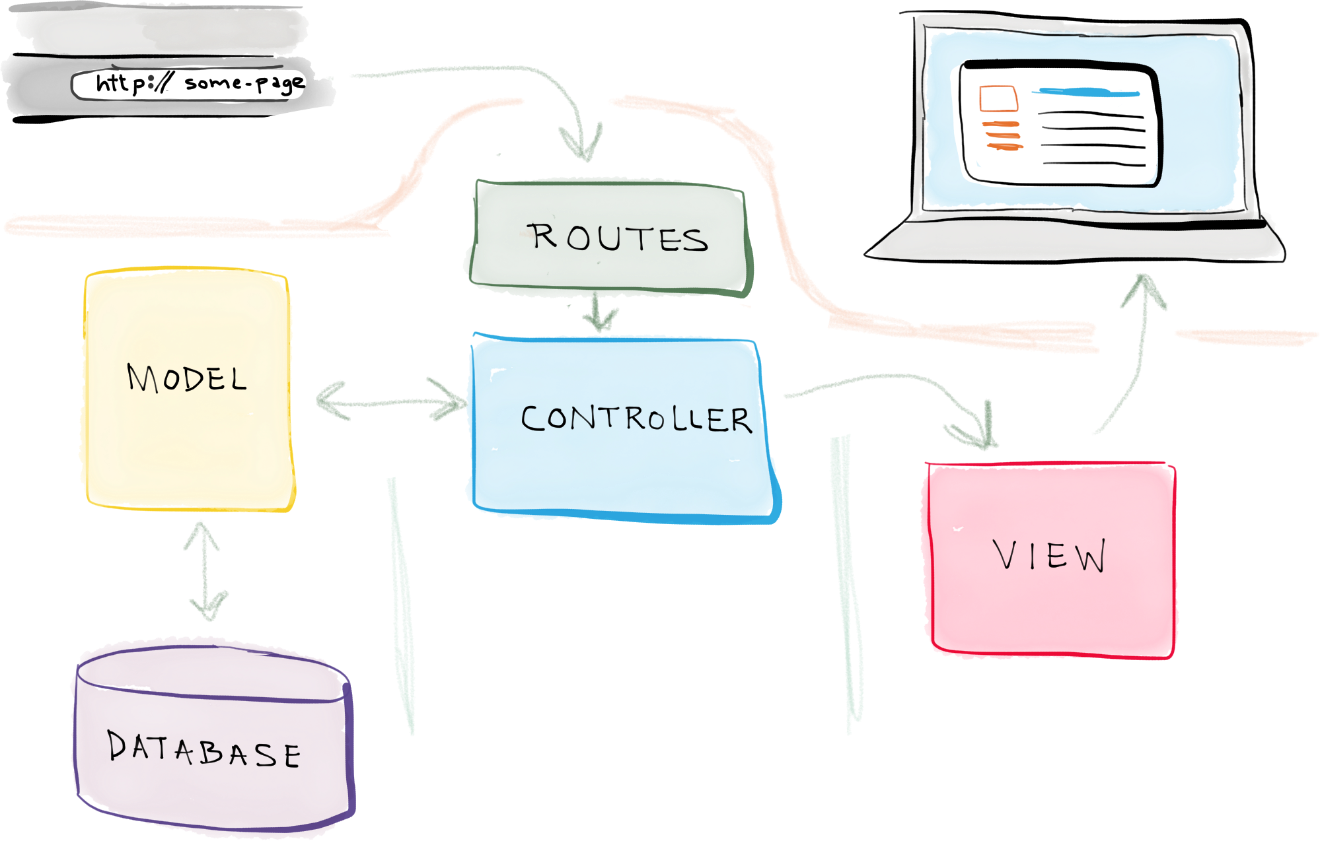

<https://www.techiediaries.com/php-laravel-crud-mysql-tutorial/>

1)change dir

cd /var/www/laravel

2)make model

$ php artisan make:model Contact –migration

Open th migration file and update it accordingly

sudo gedit /var/www/laravel/database/migrations/2019_08_30_101206_create_contacts_table.php

$table->string('first_name');

$table->string('last_name');

$table->string('email');

$table->string('job_title');

$table->string('city');

$table->string('country');

php artisan migrate

Now, let's look at our Contact model, which will be used to interact with the contacts database table. Open the app/Contact.php and update it:

sudo gedit /var/www/laravel/app/Contact.php

<?php

namespace App;

use Illuminate\Database\Eloquent\Model;

class Contact extends Model

{

protected $fillable = [

'first_name',

'last_name',

'email',

'city',

'country',

'job_title'

];}

## **Creating the Controller and Routes**

php artisan make:controller ContactController --resource

sudo gedit /var/www/laravel/app/Http/Controllers/ContactController.php

sudo gedit /var/www/laravel/routes/web.php

<?php

Route::get('/', function () {

return view('welcome');

});

Route::resource('contacts', 'ContactController');

## **Implementing the CRUD Operations**

sudo gedit /var/www/laravel/app/Http/Controllers/ContactController.php

update this

public function store(Request $request)

{

$request->validate([

'first_name'=>'required',

'last_name'=>'required',

'email'=>'required'

]);

$contact = new Contact([

'first_name' => $request->get('first_name'),

'last_name' => $request->get('last_name'),

'email' => $request->get('email'),

'job_title' => $request->get('job_title'),

'city' => $request->get('city'),

'country' => $request->get('country')

]);

$contact->save();

return redirect('/contacts')->with('success', 'Contact saved!');

}

public function create()

{

return view('contacts.create');

}

In the resources/views folder, create a base.blade.php file:

$ sudo gedit /var/www/laravel/resources/views/base.blade.php

<!DOCTYPE html>

<html lang="en">

<head>

<meta name="viewport" content="width=device-width, initial-scale=1.0">

<title>Laravel 5.8 & MySQL CRUD Tutorial</title>

<link href="{{ asset('css/app.css') }}" rel="stylesheet" type="text/css" />

</head>

<body>

<div class="container">

@yield('main')

</div>

<script src="{{ asset('js/app.js') }}" type="text/js"></script>

</body>

</html>

Now, let's create the create.blade.php template. First, create a contacts folder in the views folder:

mkdir /var/www/laravel/resources/views/contacts

sudo gedit /var/www/laravel/resources/views/contacts/create.blade.php

@extends('base')

@section('main')

<div class="row">

<div class="col-sm-8 offset-sm-2">

<h1 class="display-3">Add a contact</h1>

<div>

@if ($errors->any())

<div class="alert alert-danger">

<ul>

@foreach ($errors->all() as $error)

<li>{{ $error }}</li>

@endforeach

</ul>

</div><br />

@endif

<form method="post" action="{{ route('contacts.store') }}">

@csrf

<div class="form-group">

<label for="first_name">First Name:</label>

<input type="text" class="form-control" name="first_name"/>

</div>

<div class="form-group">

<label for="last_name">Last Name:</label>

<input type="text" class="form-control" name="last_name"/>

</div>

<div class="form-group">

<label for="email">Email:</label>

<input type="text" class="form-control" name="email"/>

</div>

<div class="form-group">

<label for="city">City:</label>

<input type="text" class="form-control" name="city"/>

</div>

<div class="form-group">

<label for="country">Country:</label>

<input type="text" class="form-control" name="country"/>

</div>

<div class="form-group">

<label for="job_title">Job Title:</label>

<input type="text" class="form-control" name="job_title"/>

</div>

<button type="submit" class="btn btn-primary-outline">Add contact</button>

</form>

</div>

</div>

</div>

@endsection

sudo gedit /var/www/laravel/app/Http/Controllers/ContactController.php

public function index()

{

$contacts = Contact::all();

return view('contacts.index', compact('contacts'));

}

sudo gedit /var/www/laravel/resources/views/contacts/index.blade.php

@extends('base')

@section('main')

<div class="row">

<div class="col-sm-12">

<h1 class="display-3">Contacts</h1>

<table class="table table-striped">

<thead>

<tr>

<td>ID</td>

<td>Name</td>

<td>Email</td>

<td>Job Title</td>

<td>City</td>

<td>Country</td>

<td colspan = 2>Actions</td>

</tr>

</thead>

<tbody>

@foreach($contacts as $contact)

<tr>

<td>{{$contact->id}}</td>

<td>{{$contact->first_name}} {{$contact->last_name}}</td>

<td>{{$contact->email}}</td>

<td>{{$contact->job_title}}</td>

<td>{{$contact->city}}</td>

<td>{{$contact->country}}</td>

<td>

<a href="{{ route('contacts.edit',$contact->id)}}" class="btn btn-primary">Edit</a>

</td>

<td>

<form action="{{ route('contacts.destroy', $contact->id)}}" method="post">

@csrf

@method('DELETE')

<button class="btn btn-danger" type="submit">Delete</button>

</form>

</td>

</tr>

@endforeach

</tbody>

</table>

<div>

</div>

@endsection